KINJOINTS - Model SSFC-EF St.Steel Flexible Hose Connectors

**Product Data Sheet No.** KME-SSFC-EF-FLT-2024 | **Edition:** Nov 2024 **Page 1 of 1**

**ST. STEEL FLEXIBLE HOSE CONNECTORS**

Model SSFC-EF Flexible Connectors consist of stainless-steel bellows protected by a stainless-steel outer braid and ferrules.

**Applications**

SSFC-EF Connectors are most suitable for fan coil units and sanitary equipment. The elastomeric hose allows for optimum flexibility while the braid protects the connectors against damage.

SSFC-EF Connectors compensate for pipe misalignment and isolate rotating equipment vibrations and sound transmission through the piping.

SSFC-EF connectors are easily disconnected to allow for the maintenance of equipment.

SSFC-EF Connectors are available with a variety of end fittings and materials to suit each installation.

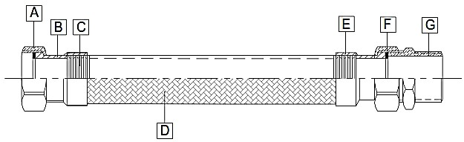

Application: Heating, air conditioning, and ventilation applications, fan heating connections, Water heaters, and Radiator connections.

Note: The images shown are for illustration purposes only and may not be an exact representation of the product.

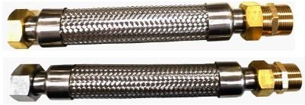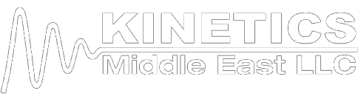

**Material Description: Available Material Ends:**

|  |  |  |
| --- | --- | --- |
| **ITEM PARTS MATERIAL** | | |
| A | FEMALE END | CARBON STEEL / BRASS / SUS304 / SS316 |
| B | CORE BAR | SUS304 |
| C | BELLOWS | SUS304 |
| D | BRAIDED WIRE | SUS304 |
| E | SEAL RINGS | SUS304 |
| F | WASHER | EPDM |
| G | MALE THREADS | CARBON STEEL / BRASS / SUS304 / SS316 |

|  |  |
| --- | --- |
| **ENDS** | **DESCRIPTION** |
| **MBFB** | MALE BRASS X FEMALE BRASS |
| **MBFS** | MALE BRASS X FEMALE STEEL |
| **MSFB** | MALE STEEL X FEMALE BRASS |
| **MSFS** | MALE STEEL X FEMALE STEEL |

**Technical Details:**

|  |  |  |  |  |  |  |  |  |
| --- | --- | --- | --- | --- | --- | --- | --- | --- |
| **NOMINAL BORE** | | **BELLOWS O.D**  **MM** | **TOTAL LENGTH** | | **MAX WORKING MAXIMUM BURST PRESSURE OFFSET PRESSURE TEMPERATURE MPA**  **MM KG/CM2 DEG.C** | | | |
| **MM** INCH | | MM INCH | |
| 15 | 1/2 | 18.7 | 200 | 8 | 20 | 20 | 200 | 6 |
| 20 | 3/4 | 25.3 | 200 | 8 | 20 | 20 | 200 | 6 |
| 25 | 1 | 32.6 | 250 | 10 | 20 | 20 | 200 | 6 |
| 32 | 1 1/4 | 41.2 | 300 | 12 | 18 | 20 | 200 | 6 |
| 40 | 1 1/2 | 47.7 | 400 | 16 | 16 | 20 | 200 | 6 |
| 50 | 2 | 62 | 400 | 16 | 15 | 20 | 200 | 6 |
| **NOTE: The Size, Total Length, Max Offset and Pressure tabulated are standard. Custom made length, Offset, Pressure are available based on requirement.** | | | | | | | | |

**DISCLAIMER:**

The information provided is intended only as a summary and general overview on matters of interest. The information is not intended to be comprehensive nor does it constitute expert advice. KINETICS Middle East LLC shall not be liable for incidental and/or consequential damages directly or indirectly sustained, nor any loss caused by not complying with relevant industry/product standards and improper use of any KINCUP products. Due to varying construction methods, any other circumstances not stated above should be brought to the attention of KINETICS Middle East LLC for review. For suitability to the prevailing site conditions, it is advised that certified testing should be conducted. It is recommended to seek further advice on your application with our technical staff prior to use.

**KINETICS Middle East L.L.C.**

PO Box: 37670, Dubai, UAE Tel: +971 4 885 73 61

[sales@kineticsgroup.ae](mailto:sales@kineticsgroup.ae)

[www.kineticsgroup.ae](http://www.kineticsgroup.ae/)